VISITOR MANAGEMENT SYSTEM USING
SERVICENOW

Milestone 3: Business Logic and Security
Objective
Implement business logic, form customization, validation rules, and user interface configurations to automate visitor management processes and improve user experience.
Step 1: Configure Form Layout
Navigation:
Open Visitor Form
Right Click
Configure
Form Layout
Arrange fields in a logical order to improve usability and data entry efficiency.
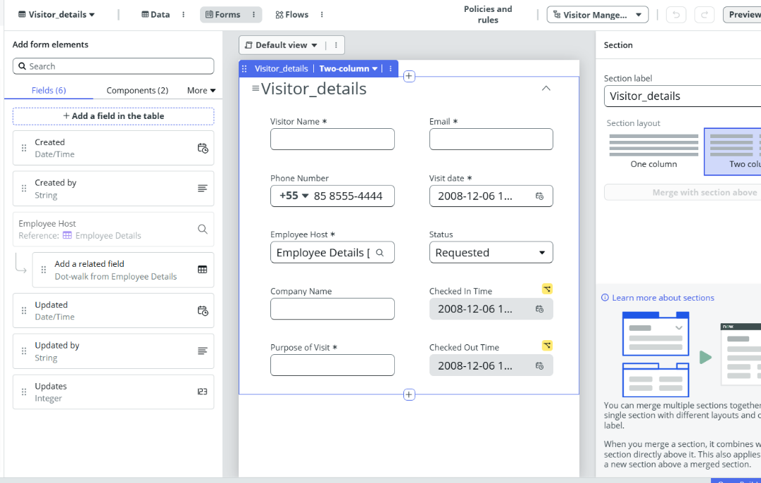
Step 2: Create UI Policies
Purpose
Dynamically control field visibility and improve the user experience by displaying relevant fields based on the visitor's status.
Navigation
System UI → UI Policies
Create New UI Policy

UI Policy 1: Display Check In Time
Table
Visitor
Condition
Status = Checked In
OR
Status = Checked Out
UI Policy Action
- Check In Time → Visible = True
- Check In Time → Read Only = True
Purpose
Displays the Check In Time field after the visitor has been checked in and prevents users from modifying the recorded value.
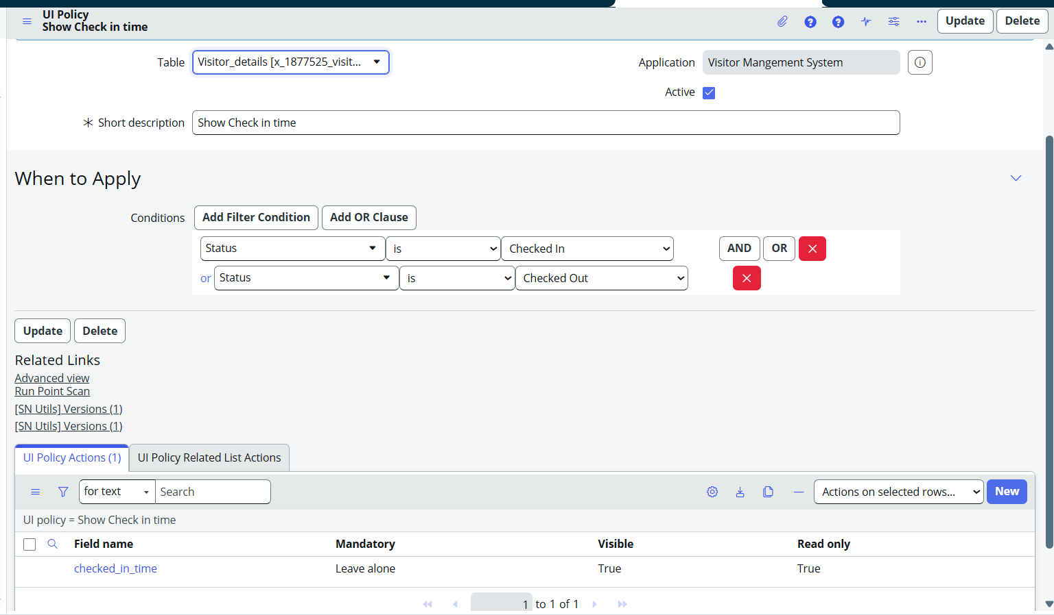
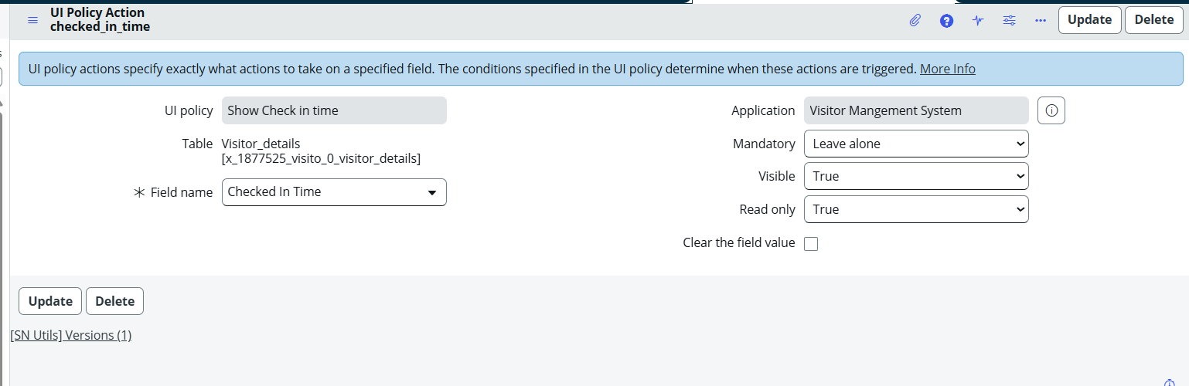

UI Policy 2: Display Check Out Time
Table
Visitor
Condition
Status = Checked Out
UI Policy Action
- Check Out Time → Visible = True
- Check Out Time → Read Only = True
Purpose
Displays the Check Out Time field only after the visitor has been checked out and prevents modification of the recorded timestamp.
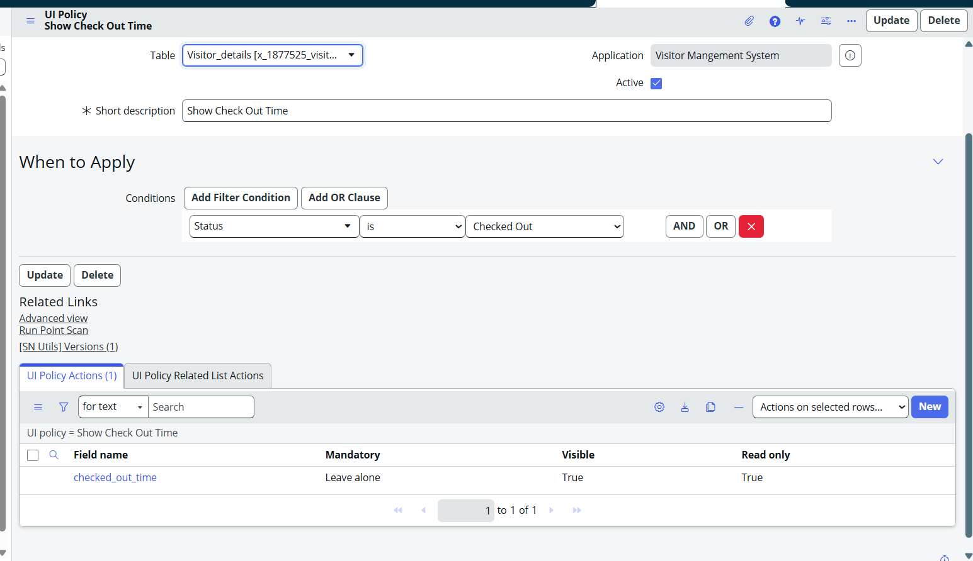
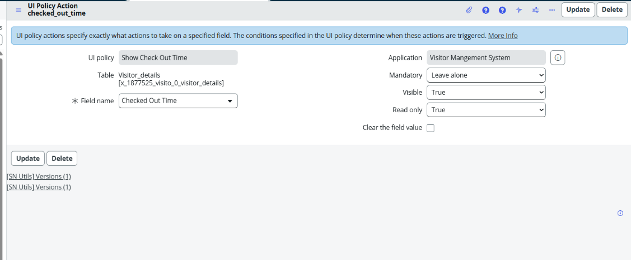

Step 3: Create Custom Role
Navigation:
sys_user_role.list
Role 1:
x_1877525_visito_0.admin
Assign role to Security.
Role 2:
x_1877525_visito_0.user.
Assign role To Employees.
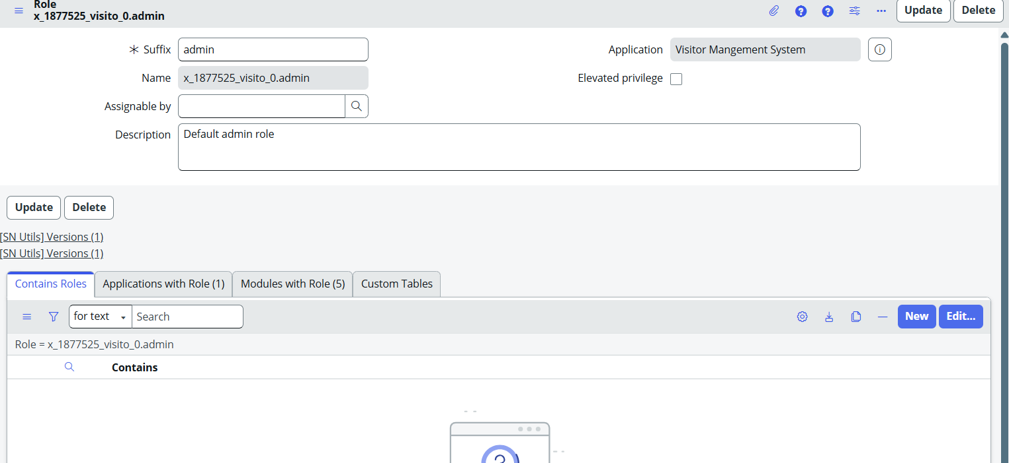
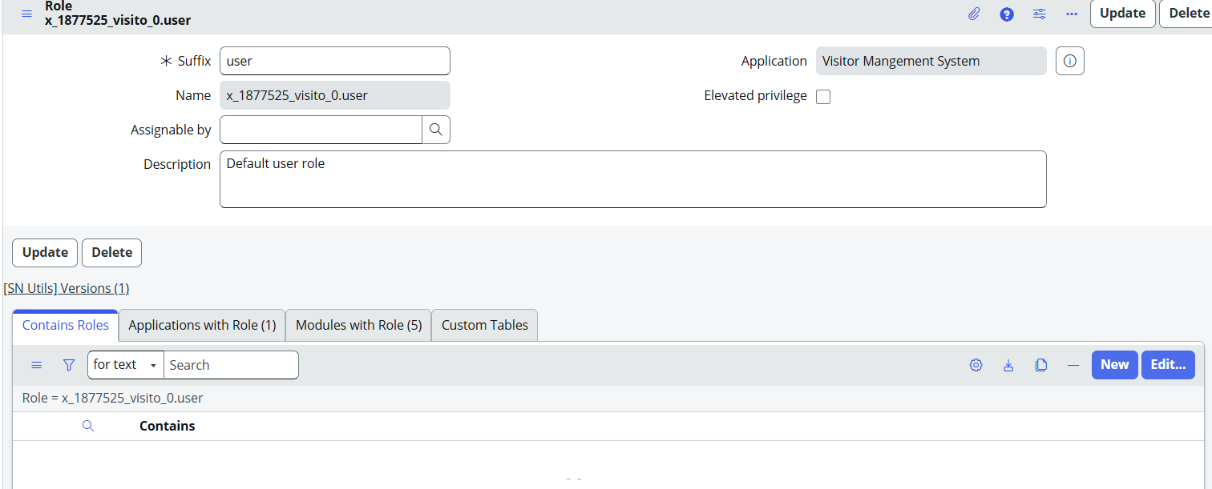
Step 4: Create UI Actions
Purpose
Provide administrators with quick actions to manage visitor requests directly from the Visitor form.
UI Actions Created
- Approve
- Reject
- Check In
- Check Out
Configuration
Each UI Action updates the visitor status and performs the required business logic.
Purpose
These actions automate the visitor approval and visit tracking process, reducing manual effort and improving operational efficiency.
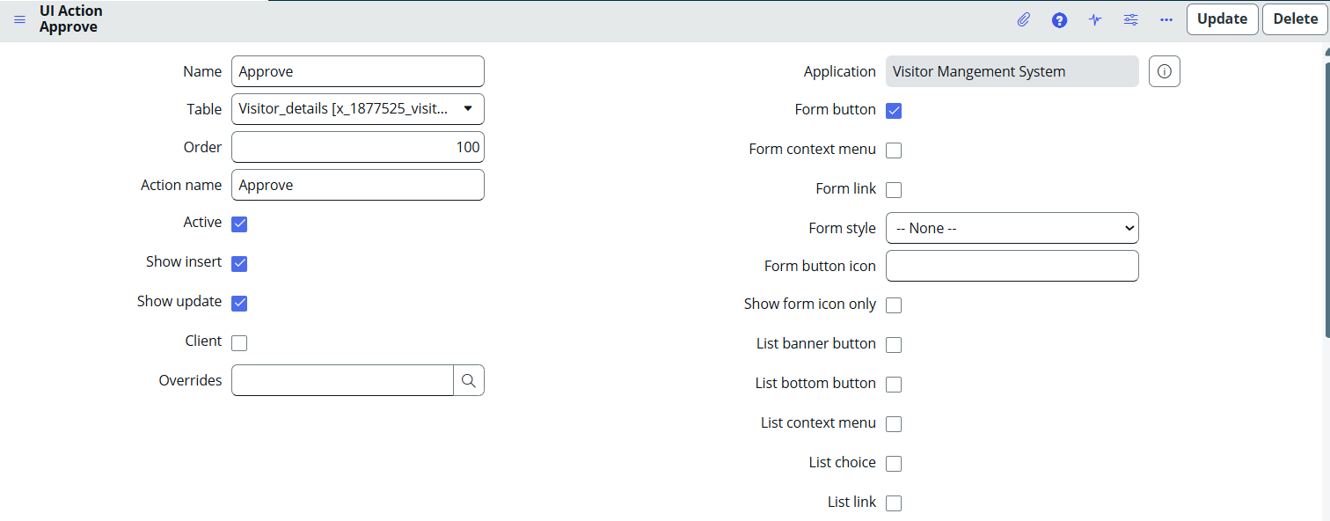

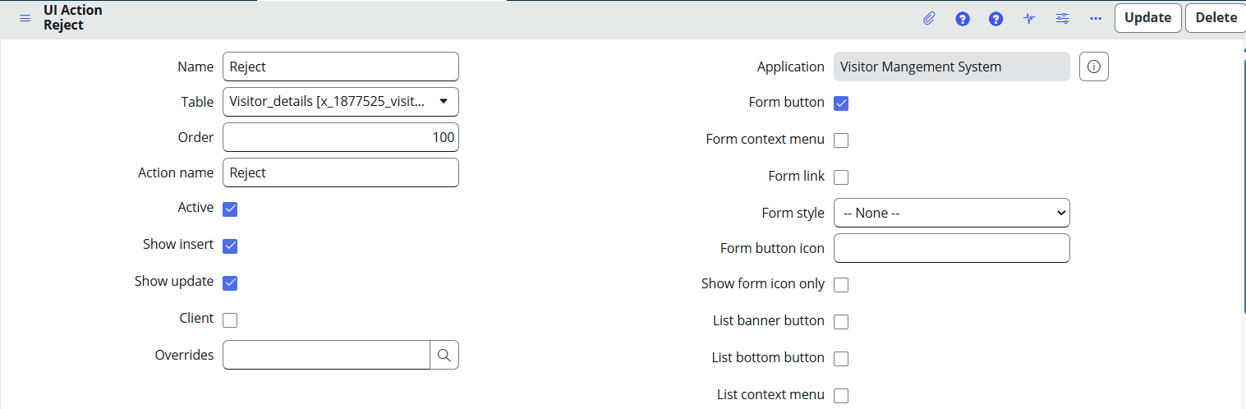
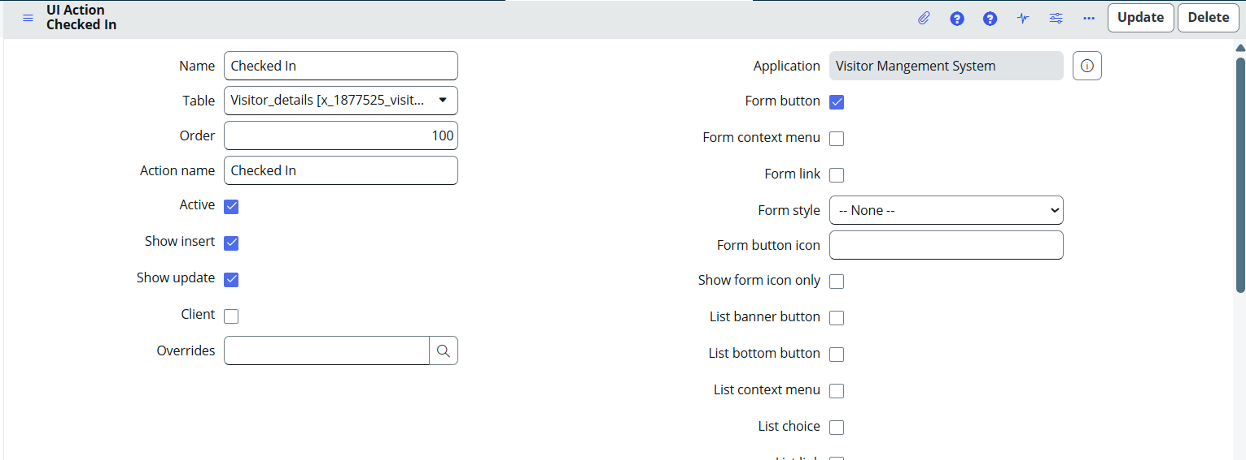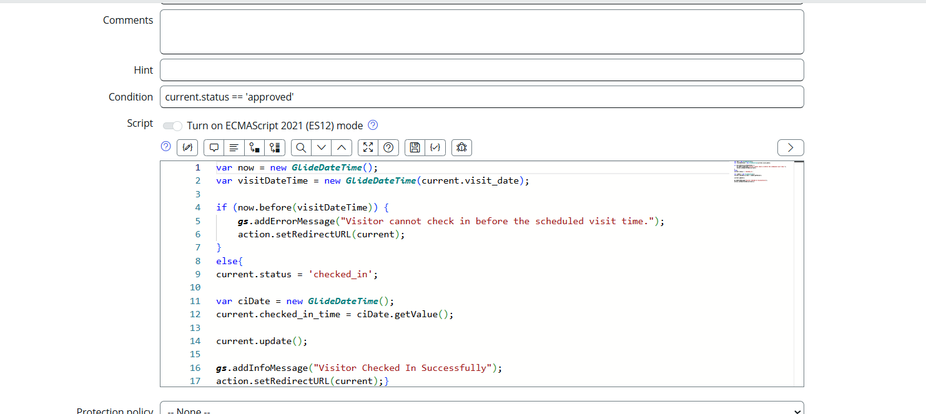

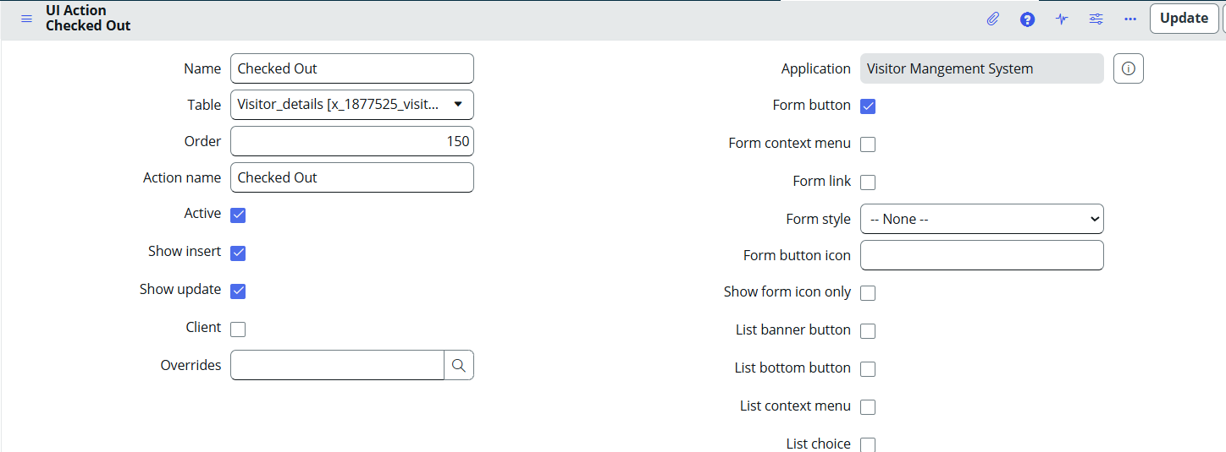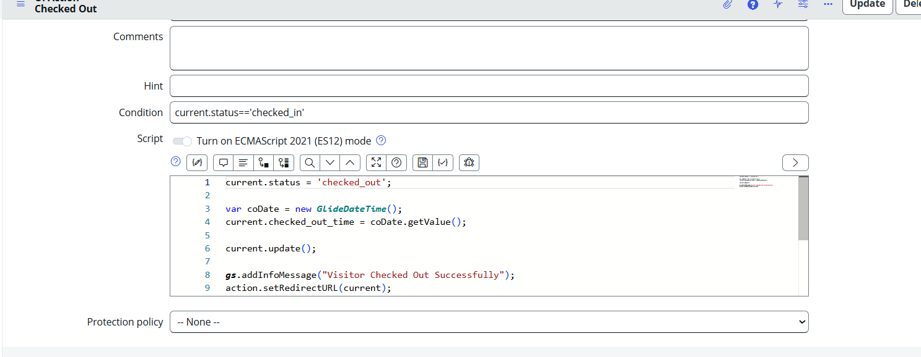

Step 5: Create Client Scripts for Data Validation
Purpose
Validate visitor request details before submission to ensure accurate and valid data is stored in the system.
Navigation
System Definition → Client Scripts
Create New Client Script

Validation 1: Visit Date Validation
The script prevents users from selecting a visit date in the past.
Result
- Past dates cannot be selected.
- Invalid visitor requests are prevented.

Validation 2: Working Hours Validation
The script ensures that visitor appointments are scheduled only during official working hours.
Allowed Time
09:00 AM – 06:00 PM
Result
- Visit requests outside working hours are rejected.
- Only valid appointment times are accepted.
- Improves scheduling and visitor management efficiency.
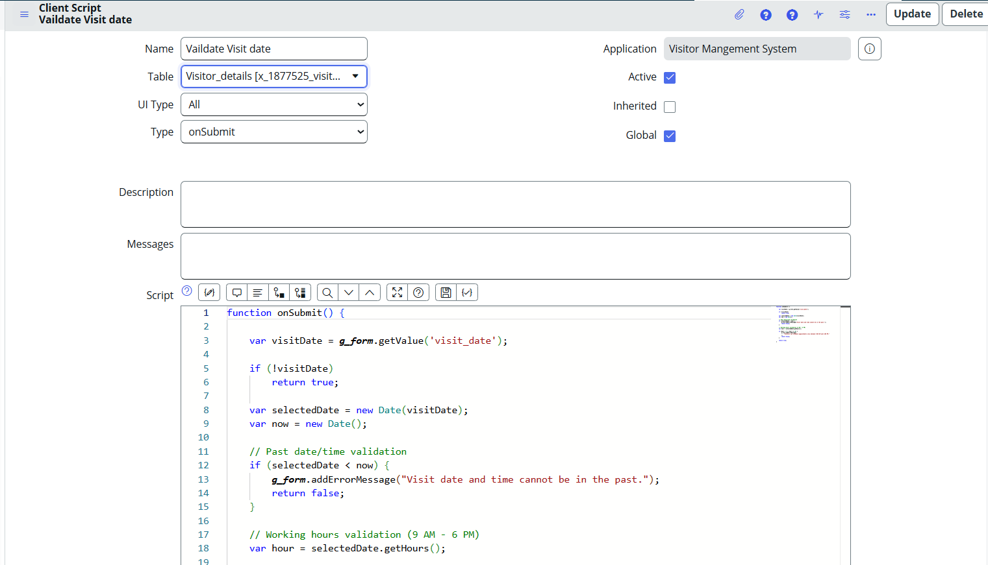

Learning Outcomes
- Learned to create and configure UI Policies.
- Implemented dynamic field visibility and read-only controls.
- Created Client Scripts for date and time validation.
- Applied business logic to enforce working-hour restrictions.
- Developed UI Actions for visitor approval, rejection, check-in, and check-out processes.
- Improved data quality through client-side validation.
- Enhanced user experience by automating visitor management workflows.

